CITY COUNCIL AGENDA
ANDREWS, TEXAS
BUSINESS & TECH CENTER
201 NW Ave D
THURSDAY, SEPTEMBER 10, 2020
5:30 P.M.

CALL THE MEETING TO ORDER
INVOCATION
- CONSENT AGENDA
- Minutes from August 27,, 2020
- Taxes Collected through August 31, 2020
- Checks written 8-21-2020 through 9-3-2020
- Departmental Reports for July 2020
- Travel Requests
- Hear Staff report from Steve Eggleston or Sara Copeland.
- Hear Public Comments from those who requested to speak on this Agenda item.
- Take Council Action.
CITIZEN REQUESTS:
- CITIZEN REQUEST – Consider Approval of a Request from Brenda Yarbrough, representing the Andrews High School Student Council, for Temporary Street Closure, October 1, 2020 for AHS Homecoming Parade (usual route) from 6:00 pm to 8:30 pm.
  - Staff Report
  - Hear Public Comments from those who signed up with City Secretary before the meeting.
  - Request motion/action from Council.

PRESENTATION:
- Hear a presentation from Freese Nichols on the Infrastructure Master Plan.
  - No action to be taken.

OLD BUSINESS:
- Consider Ord. No. 1657, on 2nd Reading, adopting the 2020-21 Budget, including the EMS / Ambulance Services (funded by Andrews County Hospital District).
  - Staff Report – Steve Eggleston
  - Hear Public Comments from those who signed up with City Secretary before the meeting.
  - Request motion/action from Council.
- Consider Ord. No. 1658, on 2^{ndt} Reading, adopting the 2020-21 Tax Rate for the use and support of municipal government.
  - Staff Report – Steve Eggleston
  - Hear Public Comments from those who signed up with City Secretary before the meeting.
  - Request motion/action from Council.

- Consider Ord. No. 1659, on 2nd Reading, amending Appendix A - Master Fee Schedule of the City of Andrews Code of Ordinances.
  - Staff Report – Steve Eggleston
  - Hear Public Comments from those who signed up with City Secretary before the meeting.
  - Request motion/action from Council.

- Consider Approval of an Economic Incentive Package for Project Spark, as presented by Morse Haynes, AEDC Director, and recommended by the AEDC Board.
  - Hear Public Comments from those who signed up with City Secretary before the meeting.
  - Request motion/action from Council.

NEW BUSINESS:
- Consider Approval of Res. No. 732 Updating the Long Range Financial Plan.
  - Staff Report – Steve Eggleston
  - Hear Public Comments from those who signed up with City Secretary before the meeting.
  - Request motion/action from Council.

- Consider Approval of Res. No. 733 Accepting the National Fitness Campaign grant.
  - Staff Report – Steve Eggleston
  - Hear Public Comments from those who signed up with City Secretary before the meeting.
  - Request motion/action from Council.

- Consider Res. No. 734 extending the disaster declaration issued by Mayoral Declaration on March 19, 2020 in response to COVID-19, a public health emergency.
  - Staff Report – Steve Eggleston
  - Hear Public Comments from those who signed up with City Secretary before the meeting.
  - Request motion/action from Council.

- Consider Approval of an Agreement with R&C MX LLC for the lease of approximately 67.5 acres of City property located on the NW corner of the Florey wellfield with the sole intent to re-open the motocross facility to the public for racing and practice.
  - Staff Report – Steve Eggleston
  - Hear Public Comments from those who signed up with City Secretary before the meeting.
  - Request motion/action from Council.

- Consider Approval of a one-time offer to buy back 40 hours of accrued vacation from employees with over 40 hours accrued vacation as of August 31, 2020.
  - Staff Report – Steve Eggleston
  - Hear Public Comments from those who signed up with City Secretary before the meeting.
  - Request motion/action from Council.

- Request topics from City Council to be placed on future Council Agenda.

- City Manager Comments:
- Next meeting: Consider appointment(s) to the AEDC Board of Directors

CERTIFICATION
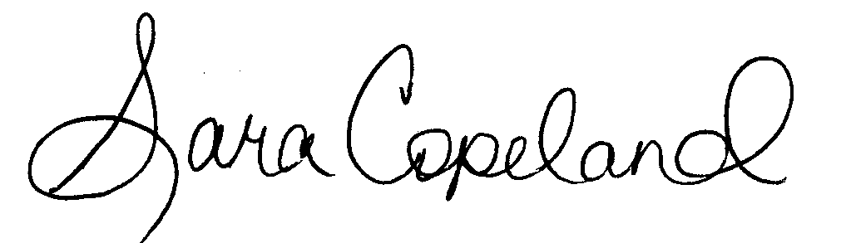
I do hereby certify that this Notice of a Meeting was posted on the outside bulletin board at City Hall, a place convenient and readily accessible to the general public at all times, and said Notice was posted on the following date and time, September 4, 2020 at 1:00 p.m., and remained so posted continuously for at least 72 hours before said meeting was convened.

______________________________
Sara Copeland, TRMC
City Secretary
NOTICE
City of Andrews Council Chamber is wheelchair accessible. Please contact the City Secretary at 432-523-4820 no later than 48 hours prior to a meeting, if you require special assistance.

